Karnataka Law Society’s

KLS GOGTE INSTITUTE OF TECHNOLOGY-590008

UDYAMBAG, BELAGAVI-59008

DEPARTMENT OF PHYSICS



Course Seminar Report

Title

“Hyperloop”

Submitted by Students of B.E. - II Semester 2020-21

|  |  |  |  |  |  |
| --- | --- | --- | --- | --- | --- |
| Sl No. | Name | USN | Roll No. | Marks | Sign |
| 1 | Shradha Mallikarjun Patil | 2GI20CS144 | I2 |  |  |
| 2 | Gouri Huddar | 2GI20EE009 | I45 |  |  |
| 3 | Omprakash Jat | 2GI20IS020 | I47 |  |  |
| 4 | Smruti Bhandiwad | 2GI20IS041 | I49 |  |  |

**INDEX:**

|  |  |  |
| --- | --- | --- |
| Sl No. | Contents | Page No. |
| 1. | Abstract | 3 |
| 2. | Introduction | 3 |
| 3. | Need for the technology | 4 |
| 4. | Design | 5 |
| 5. | Working | 7 |
| 6. | Research Programs and companies | 8 |
| 7. | Pros and cons | 12 |
| 8. | Future of hyperloop | 14 |
| 9. | Conclusion | 15 |
| 10. | References | 16 |

**1.Abstract:**

This System works on the principle of Electromagnetic attraction of forces. This system uses both Electromagnets and Permanent magnets to levitate, propel and control the pod. This type of transportation system was proposed in the USA which is an ultrahigh speed transportation system in a vacuum medium with reduced air resistance and pressure. This ultra-low pressure inside the tube causes problems for the passengers so we are solving this problem with the help of different methods for the safety of passengers due to the leakage problem

Hyperloop consists of a low-pressure tube with capsules that are transported at both low and high speeds throughout the length of the tube. The capsules are supported on a cushion of air, featuring pressurized air and aerodynamic lift. The capsules are accelerated via a magnetic linear accelerator affixed at various stations on the low pressure tube with rotors contained in each capsule. Passengers may enter and exit Hyperloop at stations located either at the ends of the tube, or branches along the tube length.

**2.Introduction:**

The **Hyperloop** is a proposed mode of passenger and freight transportation, first used to describe an open-source vactrain design released by a joint team from Tesla and SpaceX. Hyperloop is described as a sealed tube or system of tubes with low air pressure through which a pod may travel substantially free of air resistance or friction.

Elon Musk first publicly mentioned the Hyperloop in 2012. His initial concept incorporated reduced-pressure tubes in which pressurized capsules ride on air bearings driven by linear induction motors and axial compressors. From late 2012 until August 2013, a group of engineers from both Tesla and SpaceX worked on the conceptual modelling of Hyperloop. An early system design was published in the Tesla and SpaceX blogs which describes one potential design, function, pathway, and cost of a hyperloop system. According to the alpha design, pods would accelerate to cruising speed gradually using a linear electric motor and glide above their track on air bearings through tubes above ground on columns or below ground in tunnels to avoid the dangers of grade crossings. An ideal hyperloop system will be more energy-efficient, quiet, and autonomous than existing modes of mass transit.

The Hyperloop Alpha concept was first published in August 2013. The name *Hyperloop* was chosen because it would go in a loop.

**3.Need for the technology:**

The current practical modes of transport for passengers between major population centres include:

1. Road (inexpensive, slow, usually not environmentally sound)

2. Air (expensive, fast, not environmentally sound)

3. Rail (expensive, slow, often environmentally sound)

A new mode of transport is needed that has benefits of the current modes without the negative aspects of each. This new high speed transportation system has the following advantages:

1. Ready when the passenger is ready to travel

2. Inexpensive

3. Fast

4. Environmentally friendly

A new high-speed mode of transport is desired between major cities. This preliminary design study proposes a new mode of high-speed transport that reduces both the travel time and travel cost. The energy cost of this system is less than any currently existing mode of transport.

**4.Design:**

1. Capsule:

a. Sealed capsules carrying passengers that travel along the interior of the tube.

b. The capsules are separated within the tube by approximately 23 miles (37 km) on average during operation.

c. The capsules are supported via air bearings that operate using a compressed air reservoir and aerodynamic lift.

2. Tube:

a. The tube is made of steel. Two tubes will be welded together in a side-by-side configuration to allow the capsules to travel both directions.

b. Pylons are placed every 100 ft (30 m) to support the tube.

c. Solar arrays will cover the top of the tubes in order to provide power to the system.

3. Propulsion:

a. Linear accelerators are constructed along the length of the tube at various locations to accelerate the capsules.

b. Rotors are located on the capsules to transfer momentum to the capsules via the linear accelerators.

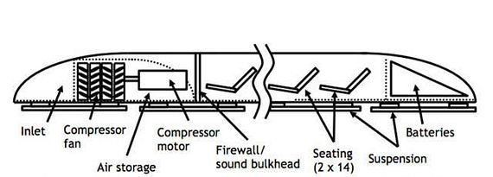

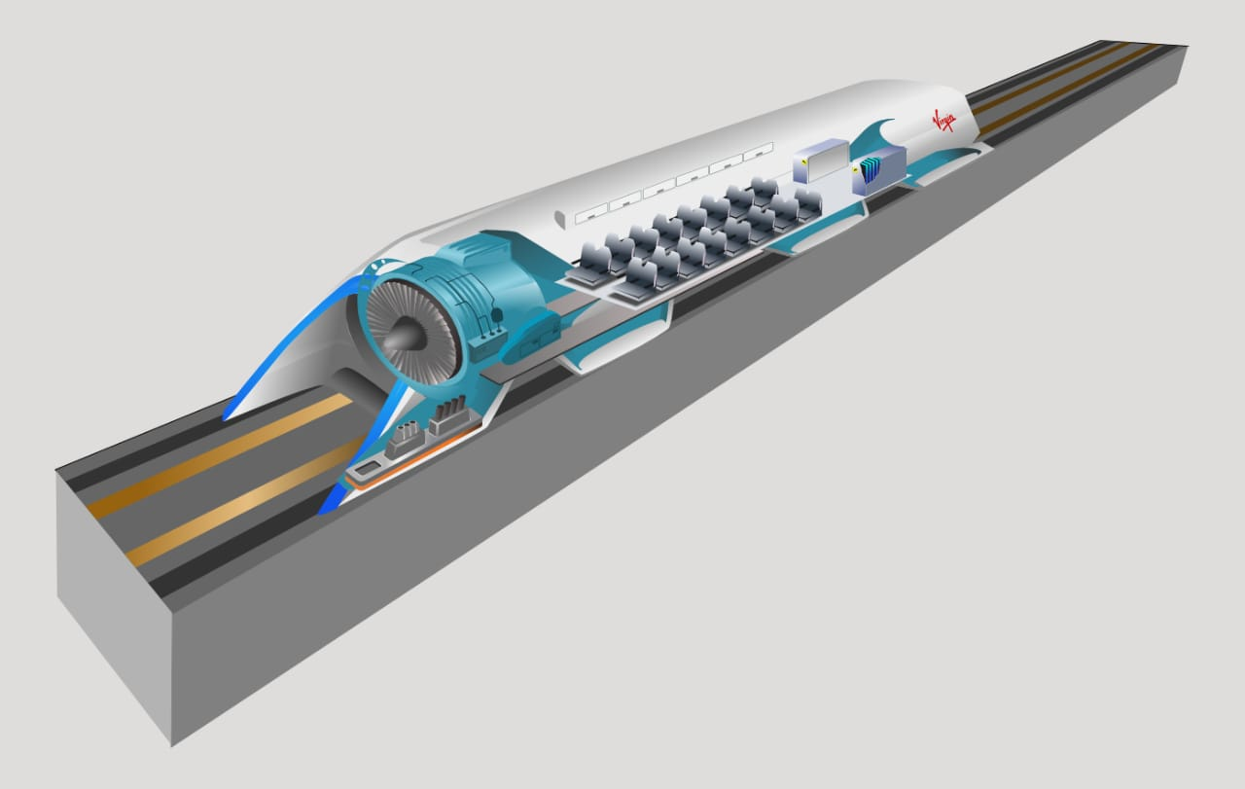

**5.Working:**

It works by propelling specially designed pressurized pods or capsules using electromagnetic force inside a near-vacuum tube to reduce air friction and drag.

The pods would accelerate to cruising speed gradually using a linear electric motor and glide above their track using passive magnetic levitation or air bearings. It is levitated and propelled forward using powerful electromagnets. This itself considerably reduces losses due to friction, as the train is literally gliding over the track and is not in contact with the track. Hence there are no frictional losses allowing the train to move at high velocities.

The absence of air in the hyperloop will further increase the efficiency by nearly eliminating losses due to air drag and make it much faster. The capsules are supported on a cushion of air, featuring pressurized air and aerodynamic lift. Residual air in the tube is captured, compressed, and forced through holes in skis attached to the bottom of the capsule. The gap between the skis and the tube during operation is between 0.5mm and 1.3mm. The air pressure in the tube is very low, a capsule travelling at 700mph will cause significant air pressure at the nose of the vehicle, which must be considered in the design. Since the tube has a larger cross-section than the capsule, some air flows around the vehicle.

**6.Hyperloop Research Programs and Companies:**

**1.TUM Hyperloop:**

In 2015 a student initiative was founded at the Technical University of Munich (TUM) to develop and build prototypes for the SpaceX Hyperloop Pod Competitions. Technical University of Munich, working closely together with the successful student initiative NEXT Prototypes, has launched the ambitious TUM Hyperloop program with the aim to design and build a full-scale ultra-high-speed ground transportation system, based on the ideas of the Hyperloop concept.

A 24-meter-long demonstrator including a full-scale pod is currently in development and it is going to be built and put into operation in 2021.

**Prototypes:**

**Pod I**

94 km/h Top Speed

600 kg Total mass

12,000 rpm Compressor speed

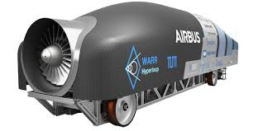

**Pod II**

324 km/h Top speed

0.9 g Peak Acceleration

50 kW Propulsion Power

85 kg Mass

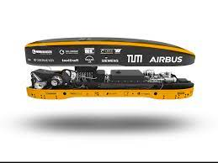

**Pod III**

467 km/h Top speed

1.2 g Peak Acceleration

240 kW Power

80 kg Mass

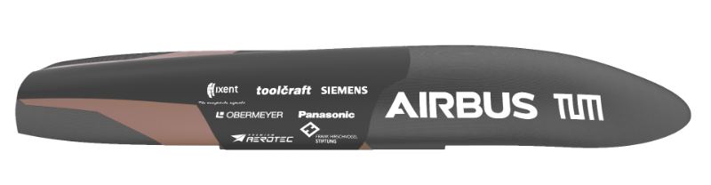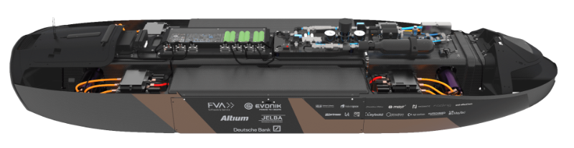

### Technical Highlights

**Pod IV**

482 km/h Top speed

2.4 g Peak Acceleration

320 kW Power

69 kg Mass

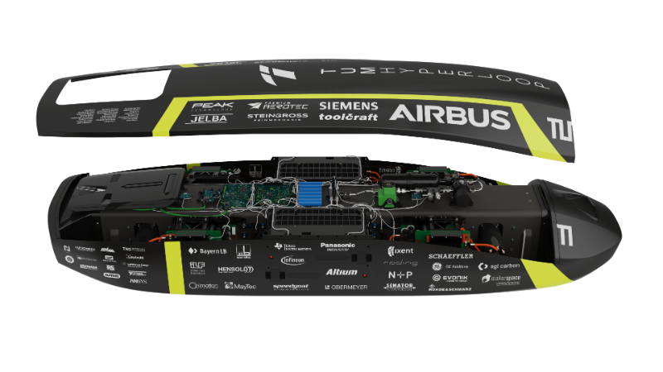

**2.Hyperloop One:**

On July 29, 2017, Hyperloop One completed phase 2, after its pod travelled nearly the full distance of the 500-metre DevLoop track in the Nevada desert and achieved record test speeds in a tube depressurized down to the equivalent of air at 200,000 feet above sea level. The Hyperloop One XP-1, the company’s first-generation pod, accelerated for 300 meters and glided above the track using magnetic levitation before braking and coming to a gradual stop. All components of the system were successfully tested, including the highly efficient electric motor, advanced controls and power electronics, custom magnetic levitation and guidance, pod suspension and vacuum system.

**3.Virgin Hyperloop:**

Virgin hyperloop successfully completed the first-ever human trial in the hyperloop pod at the DevLoop test facility in the US, where the company has previously run over 400 un-occupied tests. Two passengers, both company staff, travelled 500 metres in 15 seconds, reaching 107 mph (172 km per hour), marking the completion of the first-ever trial.

The company is working with State of Maharashtra to develop a Pune to Mumbai hyperloop which will slash journey times down to 25 minutes, support 150 million passenger trips annually, and create a thriving megaregion.

**6.Pros and cons:**

Pros:

* The technology offers very fast speed of transportation which is twice that of aircraft.
* It has very low power consumption.
* It is low cost transportation system on long run.
* It is immune to bad weather conditions.
* It is safe mode of transportation system.
* Fast, efficient and cheap to operate
* Average speeds of around 600 mph (970 km/h), with a top speed of 760 mph (1,200 km/h)
* Low power consumption
* Uses Solar Energy for power
* Open-sourced, encouraging others to take the ideas and further develop them.
* Hyperloops tubes are protected from the weather, birds, objects on railroad tracks.
* In the event of equipment or electrical failure, the system comes to a stop (does not fall from the sky).
* Automation reduces the risk of human error
* Promotes economic growth around the Hyperloop route
* Reduced freight costs and times

Cons:

* Initial cost of investment to have the system in place is very high. The long vacuum chamber manufacturing requires more technical skills. Moreover, this is costly and also risky to maintain.
* Land use rights will be concern for deployment of the project.
* It has very high risk to life when something wrong happens to the system.
* It has limited space in the train and hence people can not move freely.
* As hyperloop uses steel for track, it expands and changes shape when outside temperature is changed. This may destroy the track of hyperloop technology. This needs to be considered while designing the system based on environment of the location where it is being deployed.
* The installation requires cutting of large number of trees. This leads to environment loss.
* High cost of development and construction
* Susceptible to disruption from earthquakes, power outages or terror attacks
* No sharp curves or abrupt height changes in the route
* Potential for rapid decompression of the tube or passenger space
* Vibration and jostling caused by high speeds
* People will not be able to move freely during travel (no bathroom?)
* Unproven system

**7.Future of Hyperloop :**

#### What does the Future Hold?

The potential of Hyperloop is undoubtedly exciting and the prime focus is currently on “supporting fast, on-demand, direct delivery of palletized cargo” as opposed to TEU.

Hyperloop could be a standard mode of transporting cargo within a generation or even sooner.

The technology has attracted the attention of governments and institutions around the world and it has been tasked with solving the biggest transportation challenges of the 21st century.

The extent of Hyperloop’s success could quite easily define future trends in trade, logistics and transportation, just as previous innovations – the railway, aviation and even the container ship itself – have done.

**8.Conclusion:**

Conclusion: Being a transportation system fast is not enough; it should be durable, sustainable and safer than others. It was outlined with safety in mind by Elon Musk, known as Hyperloop. Hyperloop could transport individuals, vehicles, and cargo between Los Angeles and San Francisco in 35 minutes. Transporting 7.4 million individuals every way consistently and amortizing the expense of $6 billion more than 20 years gives a ticket cost of $20 for a single direction trip for the traveller variant of Hyperloop. The traveller just form of the Hyperloop is under 9% of the expense of the proposed traveller just fast rail framework between Los Angeles and San Francisco. Except the US many come forward to develop this new technology like Dubai, China, And India, etc. Extra innovative improvements and further advancement could almost certainly diminish this cost. It is a great privilege to the traveller which can save time and money at the same time.

**References:**

1. Tesla’s report on hyperloop back in 2013

<https://www.tesla.com/sites/default/files/blog_images/hyperloop-alpha.pdf>

2. Hyperloop Wikipedia

<https://en.wikipedia.org/wiki/Hyperloop>

3. TUM Hyperloop

<https://tumhyperloop.de/about-hyperloop/>

4. Virgin hyperloop

https://virginhyperloop.com/